GREEDY ALGORITHM

✅ Definition
A Greedy Algorithm builds a solution step by step, always choosing the best immediate (local) option hoping to reach a global optimum

📘 Core Idea
👉 “Choose best now, don’t worry about future”
- At each step → pick optimal choice
- Never reconsider previous decisions
- Works only for specific problems

🎯 WHEN TO USE GREEDY?
Greedy works only if these properties are satisfied:
✔ 1. Greedy Choice Property
- Local optimal choice leads to global optimal solution
✔ 2. Optimal Substructure
- Problem can be broken into smaller optimal subproblems

⚙️ GENERAL ALGORITHM
Start with initial state
While solution not complete:
Choose best option available
Add it to solution
Update problem
Return solution

🔹 EXAMPLE: COIN CHANGE
Problem
Coins = [1, 2, 5, 10], Amount = 39
Steps
- Pick 10 → remaining 29
- Pick 10 → remaining 19
- Pick 10 → remaining 9
- Pick 5 → remaining 4
- Pick 2 → remaining 2
- Pick 2 → remaining 0
✔ Total coins = 6

⏱ Time Complexity
- Sorting: O(n log n)
- Selection: O(n)
👉 Overall: O(n log n)

💾 Space Complexity
- O(1)

⚠️ WHERE GREEDY FAILS
Example
Coins = [18, 10, 1], Amount = 20
Greedy Result
18 + 1 + 1 = 3 coins
Optimal Result
10 + 10 = 2 coins
👉 Greedy fails ❌

🔥 POPULAR GREEDY ALGORITHMS
- Fractional Knapsack
- Dijkstra’s Algorithm
- Kruskal’s Algorithm
- Prim’s Algorithm
- Huffman Coding

🎯 CHARACTERISTICS
✔ Simple and easy
✔ Fast (efficient)
✔ Makes local decisions
❌ Does not backtrack
❌ Not always optimal

⚖️ GREEDY vs DYNAMIC PROGRAMMING
Feature | Greedy | Dynamic Programming
Approach | Local optimal | Global optimal
Speed | Faster | Slower
Complexity | Low | High
Accuracy | Not always optimal | Always optimal

🔄 WITH vs WITHOUT GREEDY
✔ With Greedy
- Fast solution
- Easy implementation
- Works for optimization problems
❌ Without Greedy (DP/Brute Force)
- Slower
- More accurate
- Handles complex cases

🧠 FINAL MEMORY TRICK
👉 Greedy = “Take best now”
👉 Works only when:
- ✔ Greedy choice property
- ✔ Optimal substructure

🧾 FINAL 5-LINE SUMMARY (EXAM GOLD)
- Greedy builds solution step-by-step
- Chooses best local option
- Fast and simple
- Not always optimal
- Used in optimization problems
GREEDY ALGORITHMS (IMPORTANT TOPICS)
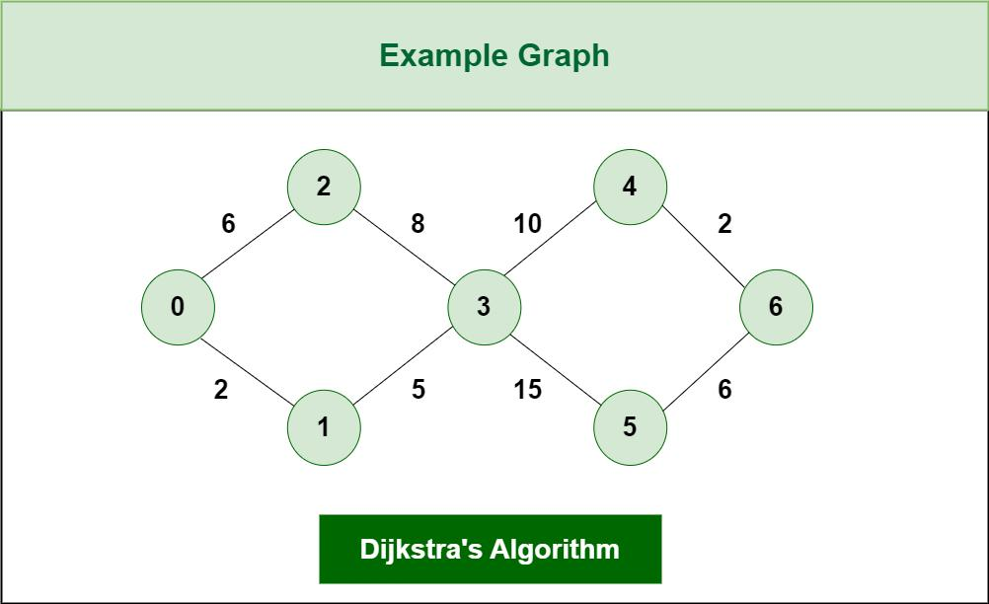
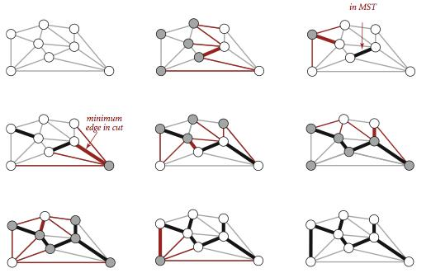
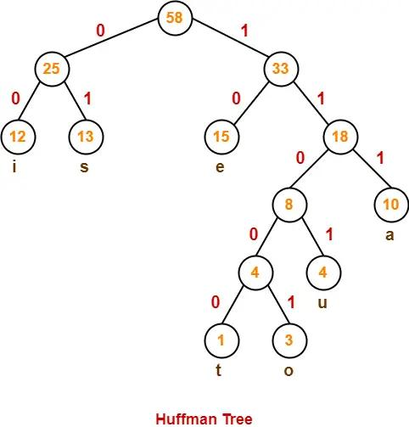
6

🔹 1. Fractional Knapsack
✅ Definition
Maximize profit by selecting items fractionally based on value/weight ratio

📘 Idea
- Compute ratio = value/weight
- Pick highest ratio first
- Take fraction if needed

⚙️ Algorithm
- Calculate ratio
- Sort items (descending ratio)
- Pick items until capacity full

⏱ Time Complexity
- O(n log n) (sorting)
💾 Space Complexity
- O(1)

🎯 Use Case
- Resource allocation
- Budget optimization

✔ Pros
- Optimal solution
- Efficient
❌ Cons
- Not applicable to 0/1 knapsack

🔄 With vs Without
- ✔ With fractional → optimal
- ❌ Without (0/1) → greedy fails

🔹 2. Dijkstra’s Algorithm
✅ Definition
Finds shortest path from source to all vertices

📘 Idea
- Always pick nearest node
- Update distances

⚙️ Algorithm
- Initialize distances
- Pick minimum distance node
- Relax edges
- Repeat

⏱ Time Complexity
- O(V²) or O(E log V)
💾 Space Complexity
- O(V)

🎯 Use Case
- GPS navigation
- Network routing

✔ Pros
- Fast
- Accurate
❌ Cons
- Doesn’t work for negative weights

🔄 With vs Without
- ✔ With non-negative edges → works
- ❌ With negative edges → fails

🔹 3. Kruskal’s Algorithm
✅ Definition
Finds Minimum Spanning Tree (MST) by selecting smallest edges

📘 Idea
- Sort edges
- Add edge if no cycle

⚙️ Algorithm
- Sort edges
- Pick smallest edge
- Check cycle (Union-Find)
- Repeat

⏱ Time Complexity
- O(E log E)
💾 Space Complexity
- O(V)

🎯 Use Case
- Network design
- Cable laying

✔ Pros
- Simple
- Works well for sparse graphs
❌ Cons
- Needs sorting
- Cycle detection needed

🔹 4. Prim’s Algorithm
✅ Definition
Builds MST starting from a node

📘 Idea
- Grow tree by adding minimum edge

⚙️ Algorithm
- Start from any node
- Add smallest edge
- Expand tree

⏱ Time Complexity
- O(E log V)
💾 Space Complexity
- O(V)

🎯 Use Case
- Network design

✔ Pros
- Efficient for dense graphs
❌ Cons
- Needs priority queue

🔄 Prim vs Kruskal
Feature | Prim | Kruskal
Approach | Vertex-based | Edge-based
Best for | Dense graphs | Sparse graphs

🔹 5. Huffman Coding
✅ Definition
Used for data compression

📘 Idea
- Assign shorter codes to frequent characters

⚙️ Algorithm
- Count frequency
- Build min heap
- Merge nodes
- Generate codes

⏱ Time Complexity
- O(n log n)
💾 Space Complexity
- O(n)

🎯 Use Case
- File compression (ZIP, JPEG)

✔ Pros
- Efficient compression
❌ Cons
- Needs extra structure

🔥 6. Traveling Salesman Problem (TSP)
✅ Definition
Find shortest path visiting all cities once and returning to start

📘 Key Point
- NP-Hard problem
- No efficient exact solution

🎯 Use Case
- Logistics
- Delivery routes

❌ Why Greedy Fails
Greedy picks nearest city → may not give optimal solution

✔ Greedy Approach
- Choose nearest unvisited city
👉 Gives approximate solution only

⏱ Complexity
- Exact solution → O(n!)

🧠 FINAL REVISION SUMMARY
Algorithm | Type | Key Idea
Knapsack | Greedy | Ratio
Dijkstra | Greedy | Shortest path
Kruskal | Greedy | Smallest edge
Prim | Greedy | Grow MST
Huffman | Greedy | Frequency
TSP | NP-Hard | No optimal greedy

🧾 FINAL 5-MARK ANSWER
- Greedy algorithms choose locally optimal solutions
- Used in optimization problems
- Examples: Knapsack, Dijkstra, MST, Huffman
- Fast but not always optimal
- TSP is NP-Hard → greedy gives approximate solution

🧠 🔷 GREEDY ALGORITHMS — WORKING & STEPS

🔹 1. Fractional Knapsack
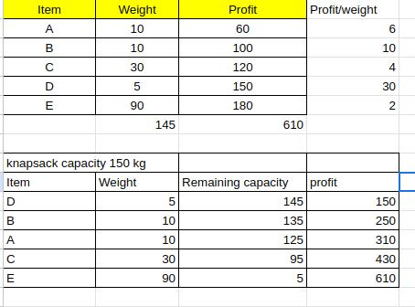
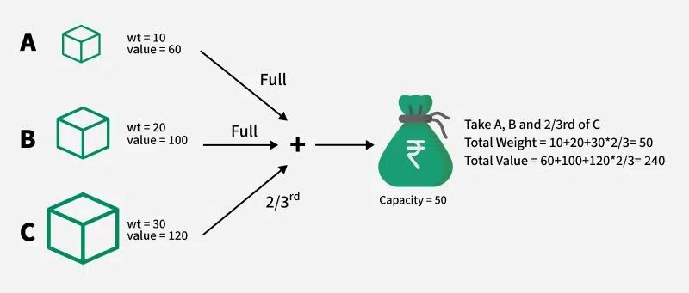
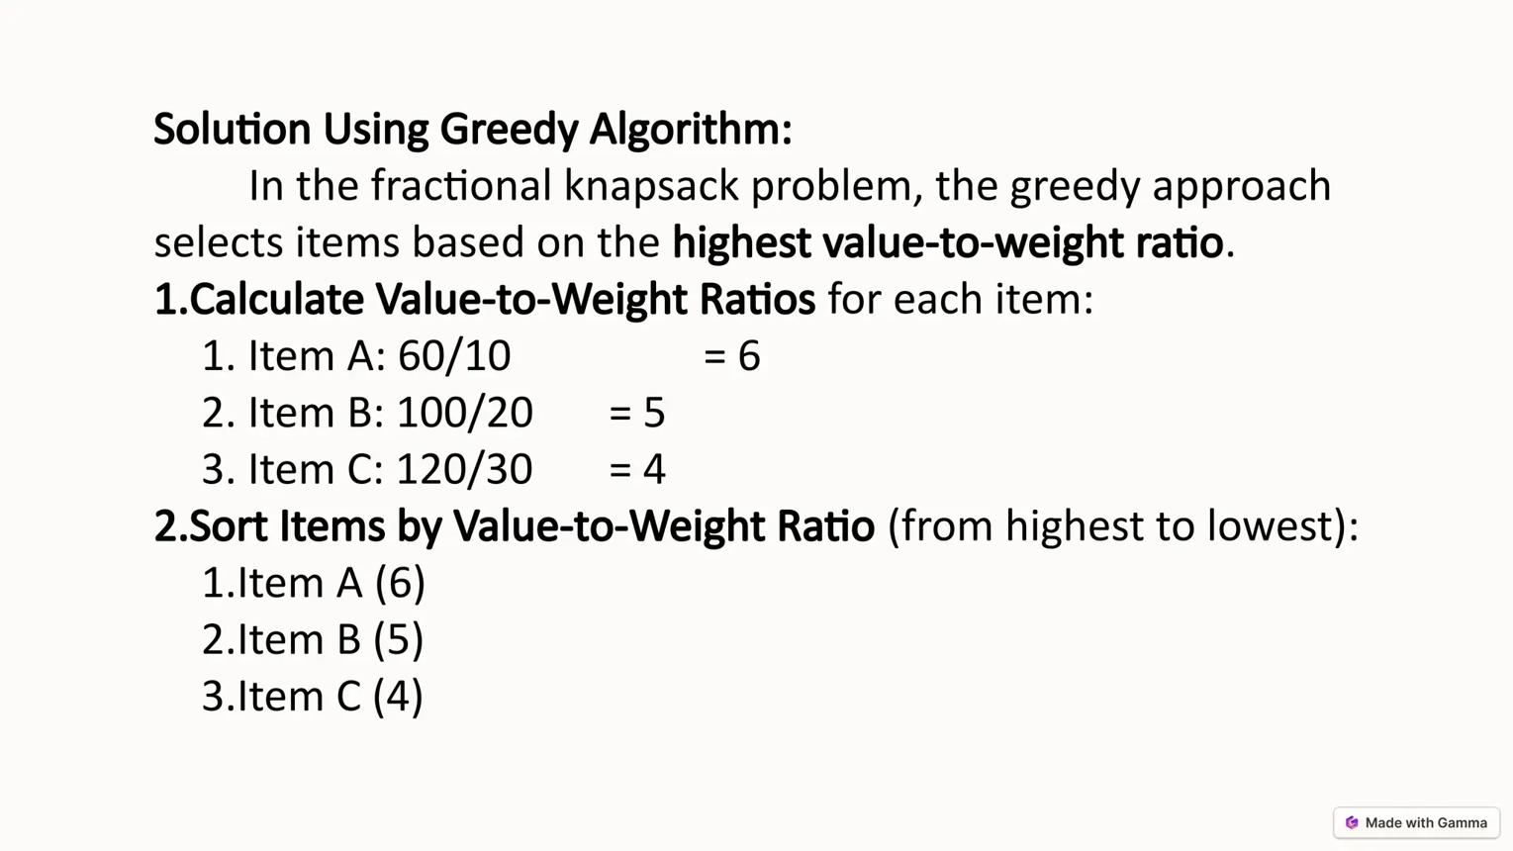
6
⚙️ Working
Select items based on maximum value/weight ratio and fill knapsack, allowing fractions.
📌 Steps
- Compute ratio = value / weight for each item
- Sort items in descending order of ratio
- Pick items one by one
- If item fits → take full
- Else → take fraction of it
- Stop when capacity is full

🔹 2. Dijkstra’s Algorithm
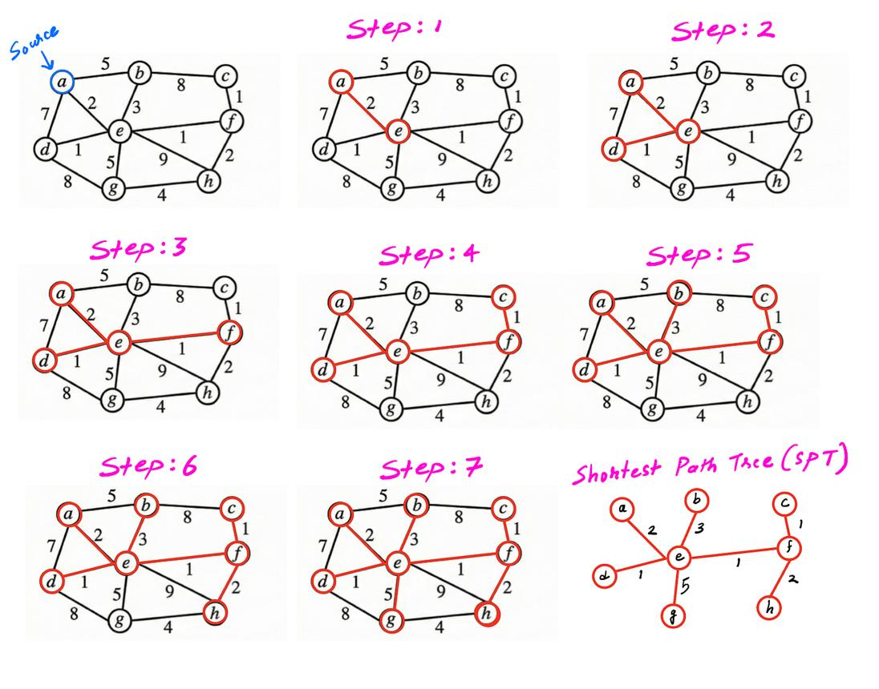
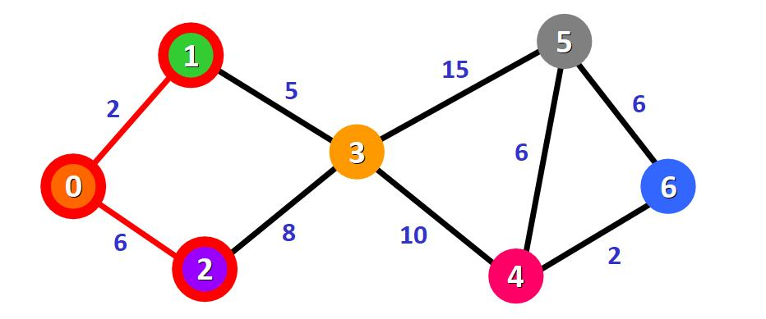
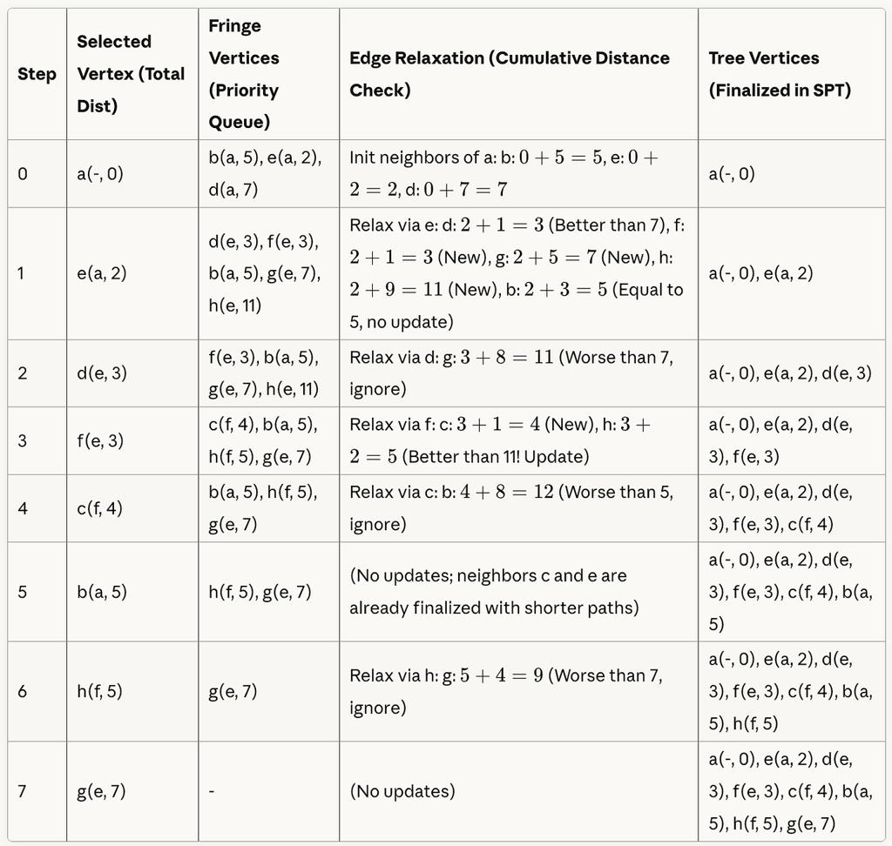
5
⚙️ Working
Finds shortest path by always choosing the nearest unvisited node.
📌 Steps
- Initialize distance of all nodes = ∞, source = 0
- Mark all nodes unvisited
- Pick node with minimum distance
- Update (relax) its neighbors
- Mark node as visited
- Repeat until all nodes processed

🔹 3. Kruskal’s Algorithm
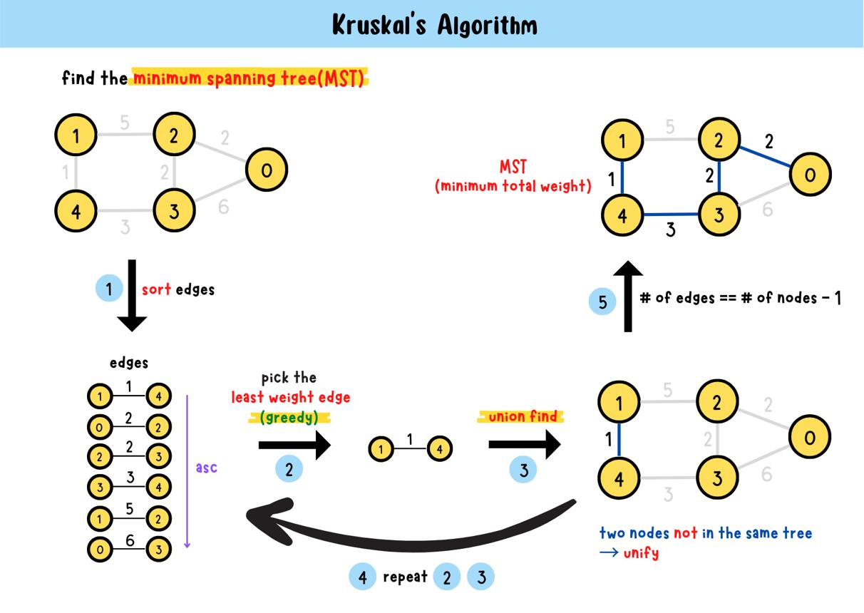
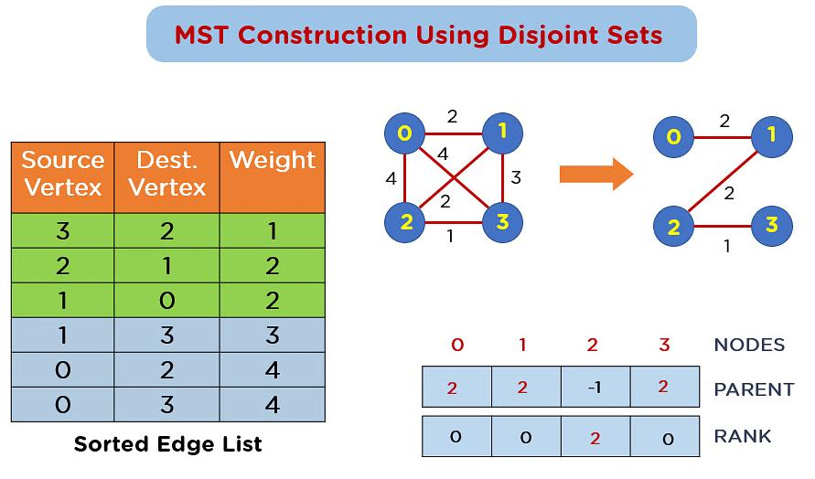
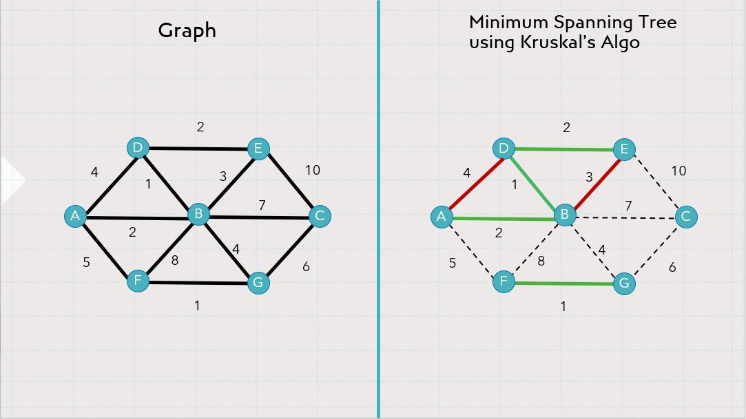
5
⚙️ Working
Build MST by selecting smallest edges without forming cycles.
📌 Steps
- Sort all edges by weight
- Start with empty MST
- Pick smallest edge
- Check if it forms cycle
- If no → include edge
- Repeat until MST has (V-1) edges

🔹 4. Prim’s Algorithm
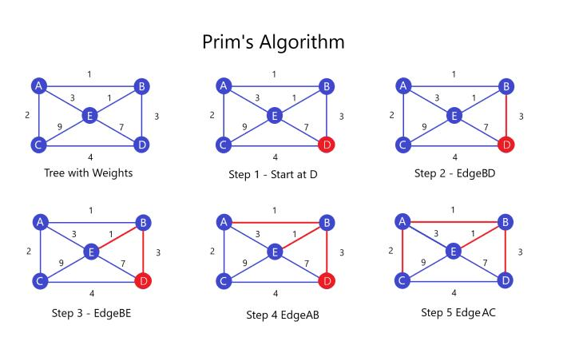
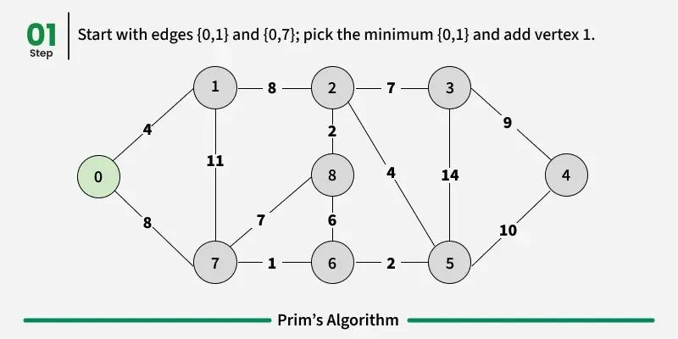
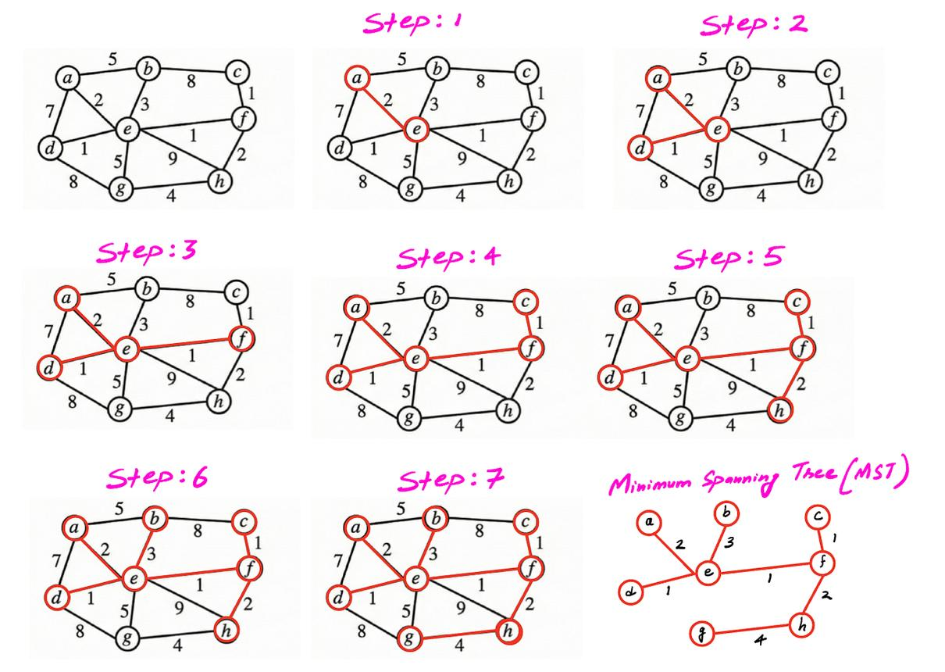
6
⚙️ Working
Build MST by expanding from a starting node using minimum edge.
📌 Steps
- Start from any node
- Mark it visited
- Select smallest edge connecting visited → unvisited
- Add edge to MST
- Mark new node visited
- Repeat until all nodes included

🔹 5. Huffman Coding
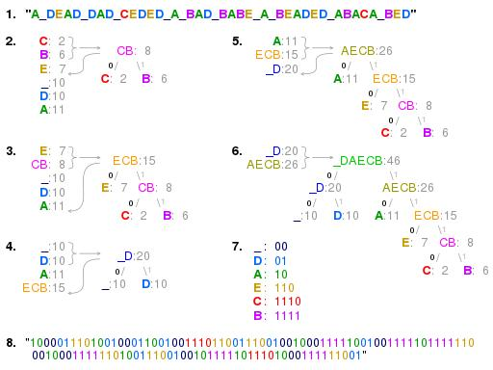
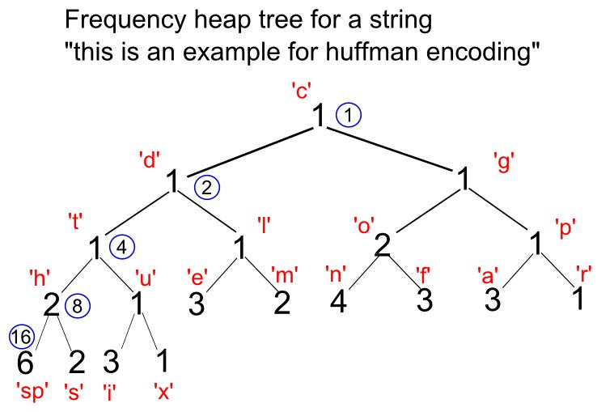
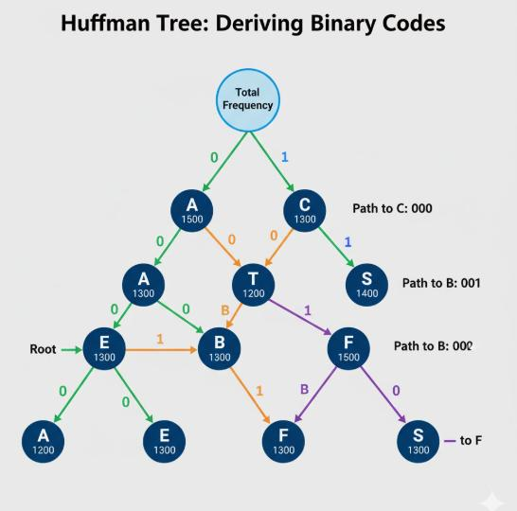
5
⚙️ Working
Creates optimal prefix codes based on frequency of characters.
📌 Steps
- Count frequency of characters
- Insert into min-heap
- Extract two smallest nodes
- Merge them into new node
- Insert back into heap
- Repeat until one node remains
- Generate codes (left = 0, right = 1)

🔥 6. Traveling Salesman Problem (TSP)
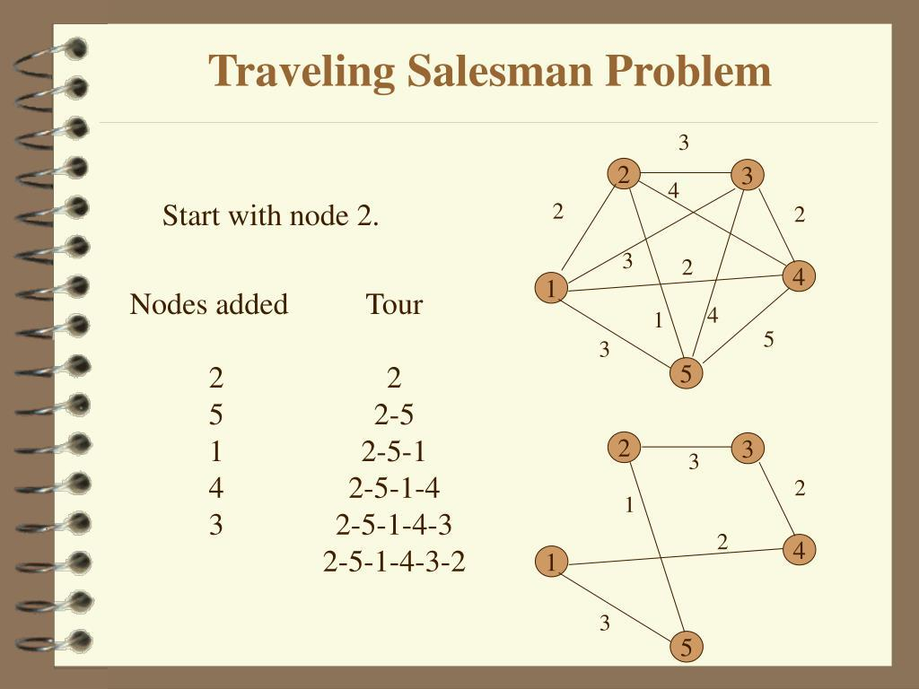
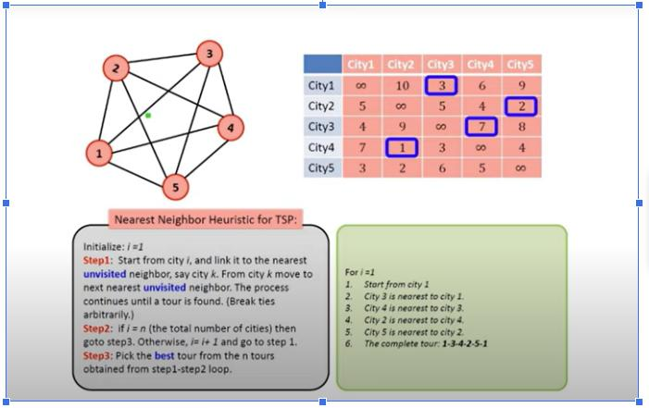
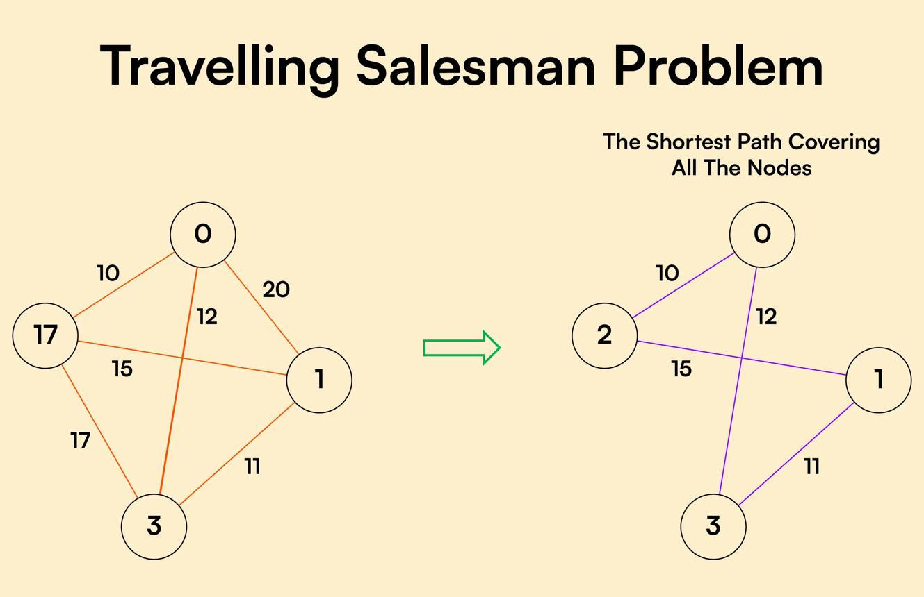
6
⚙️ Working (Greedy Approximation)
Visit nearest unvisited city at each step.
📌 Steps
- Start from a city
- Choose nearest unvisited city
- Mark it visited
- Repeat until all cities visited
- Return to starting city

⚠️ Note
- Does NOT guarantee optimal solution
- Exact solution complexity = O(n!)

🧠 FINAL QUICK MEMORY TABLE
Algorithm | Key Step
Knapsack | Pick max ratio
Dijkstra | Pick nearest node
Kruskal | Pick smallest edge
Prim | Grow MST
Huffman | Merge least freq
TSP | Pick nearest city

🧾 FINAL 5-LINE REVISION
- Greedy chooses best local option
- Steps: select → update → repeat
- Used in MST, shortest path, compression
- Fast but not always optimal
- TSP is NP-Hard

